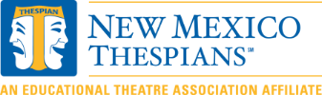
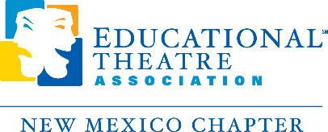
TO: All New Mexico Theatre Educators
FROM: New Mexico Thespian Board

Greetings all!
We now have registration available through an online platform.
The primary upside is that people can pay with a credit card, check or PO (even if you do not yet have the PO by entering the word Quote into the PO field). The system generates invoices automatically, but not quotes. The down side is that anyone who does not have an EdTA/Thespian registry has to create one to use the system. We will also need to collect t-shirt data, names of one acts with playwrights, and names of students for Thespys one you have registered.

https://myedta.schooltheatre.org/NC__Login

- Costs:
  - School Registration Fee: $65
  - Student Participation Fee: $35 per student
  - Thespys Fee: $15- Each student may only participate in one Thespy
  - One Act Flat Fee: $350 per school

- Grades:
  - NMAA eligibility will come from last semester’s grades or 1st quarter this year. 2.0 or better with no Fs.
- Food:
  - Food delivery is not allowed on campus. The cafeteria will be open for us. You will need to go out for meals not purchased in their cafeteria.

- The NMAA One Act Competition and Thespian Festival:
  - Festival will be in person November 9-12, 2022 at San Juan College in Farmington, NM
  - One act plays will be in person
  - Zoom will not be an option this year
  - Thespys/Individual Events will also be in person this year.
  - We will offer workshops in person this year.
  - We will offer college auditions this year.
  - We will offer the Distinguished Senior Scholarship Award this year.
  - The thirty-five minute time allotment for one acts will be in place.
  - New Mexico state theatre students are welcome to participate in Thespys with the understanding that they are not eligible to compete at the International Festival if they are not official Thespians before they register for the International Festival.
- Students must get Superior ratings to qualify for Nationals.
- For those of you who love the competition aspect, all categories involved with the one act will still be in place. The stage manager category will again count toward the final awards.
- Mask and Covid safety practices will follow the state guidelines as well as any rules in place for San Juan College and the NMAA.
- You can go to https://thespys.secure-platform.com/a/page/program-guide for current information.
Feel free to email your questions to gael.natal@rrps.net or msouers@fms.k12.nm.us .
- We cannot wait to see you in person again soon!
Look forward to talking to you soon! Gael Nata & Melissa Souers, Co-Directors, NM Thespian Board

